Student Undertaking for Ethical Academic Practice
Vidyalankar Institute of Technology, Mumbai

Assignment No: Experiment 1
Branch: CMPN Vertical: PC_PCC
Semester: V Division: A
Subject Name: Computer Networks Subject Code: PCCE11T
I hereby declare that for the assignment / academic activity submitted by me, I confirm the following statement(s) by ticking (☑) the appropriate box(es):
☑ (1) I have prepared the assignment / academic activity entirely by myself.
☐ (2) I have completed the assignment / academic activity with academic guidance or discussion from seniors / friends / peers, while ensuring the work is my own.
☐ (3) I have used AI-based tools only as an aid and have appropriately acknowledged or cited their use as per the ethical guidelines of the Institute.
☐ (4) I have used AI-based tools and directly copy-pasted content for the assignment / academic activity.
☐ (5) I have copied the assignment / academic activity from peers / friends.
I understand that selecting options (4) or (5) indicates unethical academic practice and may attract academic penalties, including rejection of the assignment or disciplinary action, as per the rules of Vidyalankar Institute of Technology, Mumbai. I submit this declaration truthfully and accept full responsibility for the same.
Student Name: Anirudh Ghanshyam Sarve Roll No.: 24102A0062
Signature: 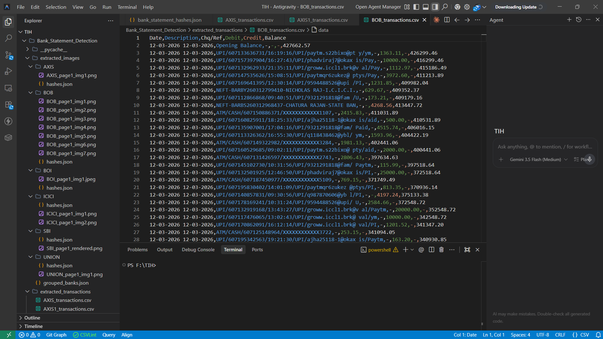 Date: 21-07-2026

